



**eProject Group 1**

**TinyTots**

TinyTots company website

**Instructors:**

Teacher. **Linh Ong Thi My**

Group 1:

Student1276235 - KHOA TRANG ANH

Student1276246 -HAN LE NGOC

Student1276254 -HOANG LE HA VIET

Student1267765 - KHA PHUNG LE

Can Tho city,

01-06-2021

# Project Team Introduction

**Project Manager:**

* Teacher: Linh Ong Thi My
* Profile -*https://aptech.cusc.vn/?tabid=111*
* Email - *otmlinh@ctu.edu.vn*

**Project Leader / Tester:**

* Name: KHOA TRANG ANH
* ID – Student1276235
* Email – takhoaa20073@cusc.ctu.edu.vn

**Analyst / Designer / Developer / Tester:**

* Name: HAN LE NGOC
* ID -Student1276246
* Email – lnhana20074@cusc.ctu.edu.vn

**Implementation Engineer / Developer / Tester:**

* Name: HOANG LE HA VIET
* ID - Student1276254
* Email – lhvhoanga20075@cusc.ctu.edu.vn
* Name: KHA PHUNG LE
* ID - Student1267765
* Email – *Plkhaa20121@cusc.ctu.edu.vn*

CONTENTS

Project Team Introduction 2

Problem Statement 4

Customer Requirement Specification (CRS) 5

Architecture and Design of the System 8

SiteMap 8

# Problem Statement

Shopping for a child is often tedious, especially if it means carting your children from one shop to another. At the end of the shopping spree, nerves are frayed, and the entire family is left in a bad mood.  
  
Though ecommerce marketplaces and malls have brought about more convenience, there is nothing like visiting one store and finding everything your child needs right there.  
  
Understanding this gap, “TinyTots” Retail was founded to help parents find everything they need for their children under one roof.  
  
“TinyTots” Retail operates multi-brand kids’ outlets for all needs and occasions for children aged 0-12 years. The stores today carry anywhere between 1,000 and 3,000 SKUs, including infant fashion, kids fashion, baby essentials, toys, accessories, baby care, and hard goods. They opened its first store in the main city  and now there are around 100 stores across India.

Now they wish to extend the the business online with the help of a website. You need to develop a website for TinyTots based on following requirements.

The website is to be developed for the Windows Platform using HTML5, JavaScript and Geolocation. The site should work well in all leading browsers including Chrome, IE, Firefox etc.

# Customer Requirement Specification (CRS)

**Client**: Several manufacturing companies in making of packaged drinking water, household chemicals, pharmaceuticals, edible oils, liquor, hare care, pesticide etc.

**Business/Project Objective:**

* Creating product with good quarity, nice designs, reasonable prices.
* Attract many customers at home and abroad.

**Inputs provided by the client:**

* **Inputs to the existing system:**
* General infomatin about website:
* Logo, banner, slogan, purpose of website.
* Information of members in team who create this website.
* Product:
* Images, ProductID, ProductName.
* Price, Detail Product.
* Customer provide:
* Registered Customer information (CustomerID, CustomerName, gender, birthday, email, phone, address).
* Feedback of Customer.
* **Outputs from the existings system:**
* Display product list, product detail.
* Display Customer list.
* Introduce company.
* **Process involved in the application:**
* Check login and sign up registered information from Customer.
* Show specification and pricing of bottles on the same images.
* Show gallery section can be for viewing different images.
* Get feedback from Customer.
* **Expected delivery dates: 22**-01-2021**List of deliverables:**
* Completed application
* Project documentation
* Installation Guide
* User Manual
* Design File

**Hardware Requirements:**

* A minimum computer system that will help you access all the tools in the courses is a Pentium 166 or better
* 64 Megabytes of RAM or better
* CPU: Intel Pentium III above
* RAM: 4GB above
* Network Card

**Software Requirements:**

* Notepad/HTML aditor
* Dreamweaver/Javascript
* Browser: Google Chrome, Opera, FireFox, IE 5.0/Netscap 6.0,..(Recommend Google Chrome, Opera).

**Scope of the Work (in brief):**

The Web site is to be created based on the following requirements:

* The Home Page should be created making use of Sections with a suitable logo, the header section can be added which will show images of various product images..
* The site must contain the links to navigate through any category for the information.
* The site should display a menu which will contain the options for brief introduction about the various products available, location of the shop and any other information if required.Links of bottles can be categorized like (Bottles, Jars, etc.)
* The information should be categorized according to the brand names of the products like if a User wants to see only “funskool” products or any other company products then he/she can click on a Link/button/menu etc and can see only that Brand products.
* When a user selects any particular brand, a list of products for that brand will be displayed
* A brief summary of features of the products should be displayed on the Web Page along with the picture but detailed Features should be stored in Individual Word documents which can be downloaded or viewed by the User who wishes to see the same.
* The user should also be able to compare the various products of different as well as similar brands.
* “Contact Us” will have the Address of the Company which should be displayed using GeoLocation API (eg. GoogleMaps) and the email address which when clicked will invoke the local mail client from where they can send an email.

# Architecture and Design of the System

The application will have a client-server architecture.

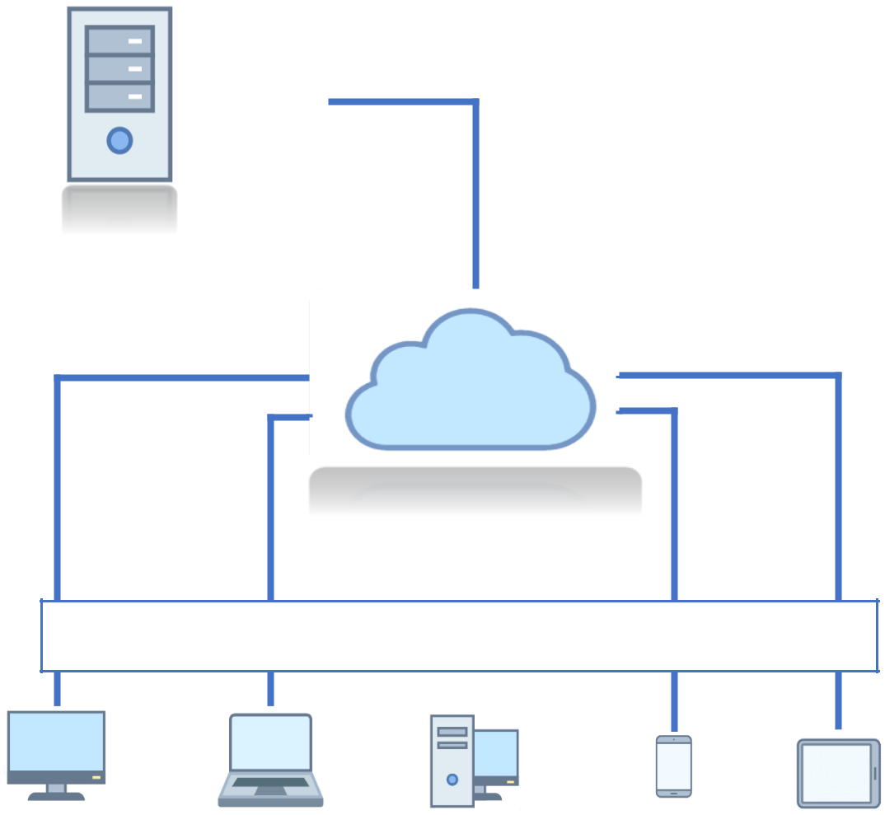

# SiteMap

*Figure 1 – Client-server architeture architecture*

**Clients**

**Network**

**Server**

Baby care

care

Home

About us

Store D

Store C

Store A

care

Store B

Fashion

care

Toys

care

Wellness & hygiene

care

Categories

Category

care

About us

care

Store

Help

care

Contact us

care

Footer

News

nnnn

Franchise

nnnn

FAQ

Brands